Name – Shaurya Srinet

Reg No – RA2111032010006

Branch – CSE w/s in IoT

Section – T2

Object Oriented Design and Programming

Assignment: Week 9: -

2. Ram and shiva are working as accountants in bank. They need to know all the arithmetic operations to verify the accounts. Since they are weak in mathematics, they found difficulty in doing such arithmetic operations. Help them to check accounts by applying arithmetic operations including add, subtract, multiply and divide using class template.

Code: -

#include <iostream>

using namespace std;

template <class T1>

class Bank

{

public:

T1 a;

T1 b;

void display()

{

cout<<"Enter two number: -\n";

cin>>a>>b;

cout<<"\nAddition = "<<a+b<<"\nSubtraction = "<<a-b<<"\nMultiplication = "<<a\*b<<"\nDivision = "<<a/b<<endl;

}

};

int main()

{

Bank<int>b1;

Bank<float>b2;

b1.display();

b2.display();

return 0;

}

Input and Output: -

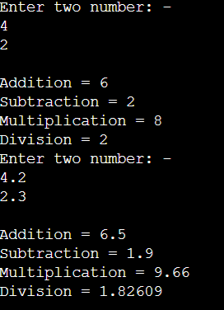

4. Write a program to define the function template for calculating the square of given numbers with different data types.

Code: -

#include <iostream>

using namespace std;

template <typename Sq>

Sq Square(Sq a)

{

Sq r;

r=a\*a;

return r;

}

int main()

{

int k1;

float k2,a;

cout<<"Enter a number: ";

cin>>a;

k1=Square(a);

k2=Square(a);

cout<<"Square of int = "<<k1<<"\nSquare of float = "<<k2;

return 0;

}

Input and Output: -

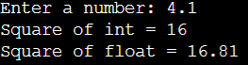

6. Write a program to illustrate how to define and declare a class template for reading two data items from the keyboard and to find their sum.

#include <iostream>

using namespace std;

template <class T1>

class Test

{

public:

T1 a;

T1 b;

void display()

{

cout<<"Enter two numbers: -\n";

cin>>a>>b;

cout<<"Addition = "<<a+b<<"\n\n";

}

};

int main()

{

Test<int>b1;

Test<float>b2;

b1.display();

b2.display();

return 0;

}

Input and Output: -

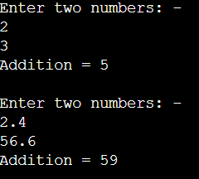

7. Write a program to demonstrate the use of special functions, constructor and destructor in the class template. The program is used to find the biggest of two entered numbers.

Code: -

#include <iostream>

using namespace std;

template <class T1>

class Max{

public:

T1 a,b;

Max(T1 A, T1 B){

a=A;

b=B;

}

T1 maximum(){

if(a>b)

return a;

else

return b;

}

~Max(){

cout<<"Destructor Called\n";

}

};

int main(){

int a,b;

float c,d;

cout<<"Enter two integer numbers: ";

cin>>a>>b;

Max <int> obj1(a,b);

cout<<"Enter two float numbers: ";

cin>>c>>d;

Max <float> obj2(c,d);

cout<<"Maximum integer: "<<obj1.maximum()<<endl;

cout<<"Maximum float: "<<obj2.maximum()<<endl;

}

Input and Output: -

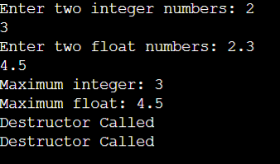

8. Write a Function Template in C++ to find the maximum number among the 3 given numbers.

Code: -

#include <iostream>

using namespace std;

template <typename La>

La Large(La a, La b, La c)

{

if(a>=b&&a>=c)

return a;

else if(b>=a&&b>=c)

return b;

else

return c;

}

int main()

{

int k1;

float k2,a,b,c;

cout<<"Enter three numbers: -\n";

cin>>a>>b>>c;

k1=Large(a,b,c);

k2=Large(a,b,c);

cout<<"Largest in int = "<<k1<<"\nLargest in float = "<<k2;

return 0;

}

Input and Output: -

